Elective 2: Into the World
In this elective students explore a variety of texts that deal with aspects of growing up or transition into new phases of life and a broader world. People encounter different experiences and respond to them individually. These personal experiences may result in growth, change or other consequences. Students respond to and compose a range of texts that illustrate different pathways into new experiences. They examine the features of texts that shape our knowledge, attitudes and beliefs about individuals venturing into new experiences.

Compare and Contrast Language
As you read:
- Compare and contrast the language Rita and Frank use
- Compare and contrast the worlds they are from

Instructions:
- Read Act One Scene One
- Complete All of the Work Below Including the Paragraph Answering the question:
All types of identities, ethnic, national, religious, sexual or whatever else can become your prison after a while.
How is this conveyed in the play?
- After completing the paragraph, write an introduction to the assessment task question:
While overcoming obstacles on our journey into new worlds, surprising revelations about ourselves are realised.
Do you agree with this perspective?
In your response, refer to your prescribed text and at least ONE other related text of your own choosing.

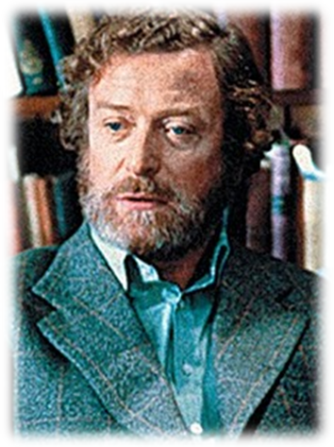 | 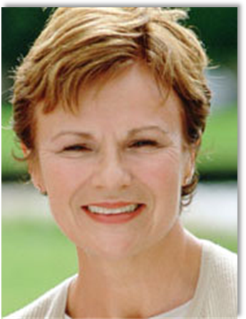
Language | Language
Describe his world | Describe her world
Satisfaction with his world | Satisfaction with her world
Transition? | Transition?
Obstacles he faces making a transition into another world | Obstacles she faces making a transition into another world
Obstacles he faces making a transition into a new phase of life | Obstacles she faces making a transition into a new phase of life
Potential rewards for making a transition into a new phase of life | Potential rewards for making a transition into a new phase of life

Answer:
- What does Rita hope to gain from Open University?
- How does Frank feel about his life? What indicates this?
Quotes | Discuss the context | Explain how this relates to into the world
Degrees for dishwashers
God, what’s it like to be free?
...I wanna know
I wanna see
But if you want to change y’ have to do it from the inside, don’t y’? Know like I’m doin’.
Do you know, I think you’re the first breath of air that’s been in this room for years.
I should have had a baby by now; everyone expects it...See, I don’t wanna baby yet. See, I wanna discover meself first.

Analyse these Symbols
Symbol | What you think it means
The door

The office

Question
All types of identities, ethnic, national, religious, sexual or whatever else can become your prison after a while.
How is this conveyed in the play?
Write at least a paragraph.
Write an introduction to the assessment questions:
While overcoming obstacles on our journey into new worlds, surprising revelations about ourselves are realised.
Do you agree with this perspective?
In your response, refer to your prescribed text and at least ONE other related text of your own choosing.

Full Metal Jacket, American Beauty and Into the World

American Beauty: http://www.youtube.com/watch?v=wSSCo3ncYag

http://www.youtube.com/watch?v=rQ0veM23apE&feature=related
http://www.youtube.com/watch?v=svoBHKceb5E&feature=related

Quotes

Character | Obstacles/sacrifices | Rewards | What it teaches us about into the world
Lester | “I’m already dead” – proleptic storytelling  She wasn’t always like this.  Feeling that he’s “lost something” | “Never too late to get it back”  He wants to retrieve something from the past that he feels is lost. Whereas Rita is future oriented his orientation is nostalgic.
Frank
Rita

Elective 2: Into the World
In this elective students explore a variety of texts that deal with aspects of growing up or transition into new phases of life and a broader world. People encounter different experiences and respond to them individually. These personal experiences may result in growth, change or other consequences. Students respond to and compose a range of texts that illustrate different pathways into new experiences. They examine the features of texts that shape our knowledge, attitudes and beliefs about individuals venturing into new experiences.

- Read Scene 1
- Review Questions from Last Class

Scene 2
She said I was off me cake
Comin’ from you it’d sound dead affected, wouldn’t it?
Like what youve got to be into is music an’ clothes an’ looking for a feller, y’ know the real qualities of life.
Is this the absolute maximum I can expect from this livin’ lark?
...there’s less to me than meets the eye.
Possessing a hungry mind is not, in itself, a guarantee of success.

- What have you learned in this scene about Frank’s life and his attitude towards it?
- There is a lot of humour in this scene. Find some examples of it, and say why they are funny.
- Explain the difficulties Rita has with literary criticism.
- What does this scene reveal about the barriers Rita faces as a working class woman?
- What significance does the door have in Rita’s first encounter in Scene one and her oiling the door in this scene?
While overcoming obstacles on our journey into new worlds, surprising revelations about ourselves are realised.
Do you agree with this perspective?
In your response, refer to your prescribed text and at least ONE other related text of your own choosing.

Setting:
A room on the first floor of a Victorian-built university in the north of England.
Symbol: physical representation of status – slightly elevated
- Rita has decided to ascend to a higher class
- Rita has decided to enter into a new world

Characterisation:
Stage directions:
He takes the bottle from the shelf and goes to a small table by the door and pours himself a large slug into the mug in his hand.
“books to reveal a bottle of whisky”
Drinking habit:
- He hides his addiction behind a facade of learning.
- He has come to a realisation that his position in life is futile. He is cynical about his world.

Quote:
Actually I don’t think I’ve looked at it for about ten years, but yes, I suppose it is.
- Perpetual ignorance of his surroundings.
- Can link this to drinking.
- He hasn’t reflected on his life.
- He drink to escape thinking about his life.
- Alcohol feeds his apathetic world view.

Language and Two Worlds Colliding – page 3
You are?
What am I?
Pardon?
What?

Allusion/characterisation
Howards End?
Yeah. It sounds filthy, doesn’t it? Page 5
- She’s insecure. Speak a different language.

Characterisation/naming - 9
I’ve called meself Rita – y’ kow, after Rita Mae Brown.
- Author of Rubyfruit Jungle - allusion
- Naming herself to...
- Needs a role model
- Irony in her choice

Page 11
“But if you want to change y’have to do it from the inside, don’t y?”

Frank: I think you’re the first breath of air that’s been in this room for years
- sterility – causes him to desire to make a transition

p. 12
Rita
Slightly out of step. I’m twenty-six. I should have had a baby now, everyone expects
I’ve tried to explain that I wanted a better way of livin’ me life

p. 13
They expect us to teach when pubs are open.

Act 1 Scene 3 and 4
- What are the obstacles and rewards you will experience as you go into the world next year?
Obstacles | Rewards

American Beauty Continued
Read Scenes 2-4
Devouring pulp fiction isn’t being well read | You seem to be under the impression that all books are literature. | I’m dead ignorant y’know.

Read Excel Guide

With the quotes we’ve used so far, write an introduction.

Scenes 3 and 4
Watch ten minutes of film
Scene 3
- Rita is less defensive about her ideas
- “I’m dead ignorant y’know” – lack of confidence in her education
- Cannot distinguish literature from pulp fiction = “they’re all books”
- Reading 3 books a week
- The gap between their worlds is still large at this point, which is shown through Rita’s inability to understand Frank
- She is far off of achieving self-knowledge – “junk” – she doubts herself – she criticises the people around her
- She idealises Frank’s world

Key Quotes from Scene | Analysis

Scene 4
- Complains about Forster
- Producing personal essays but has difficulty writing “a considered essay”
- Feels that the world classes don’t have a culture
- Frank disagrees
- Finds that reading ameliorates her feeling of emptiness and fills her with more hunger to learn
- She reaches a breakthrough in this scene – she understands the meaning of “only connect”
- Lacks an understanding of the rules of tertiary study
- Franks reminds her to “observe those rules”
- Frank is divided – he feels guilty about taking away from her subjectivity

Key Quotes from Scene | Analysis
Denny gets dead narked if I work at home. He doesn’t like me doin’ this.
They’ll tell y’ they’ve got culture as they sit there drinkin their keg beer out of plastic glasses
You know what I learned from you about art an’ literature, it feeds me, inside.
I could have told you; But you’ll have a much better understanding of something if you discover it in your own terms.

- What is Denny frightened of?
  - Denny wants to fix up his house, but not move.
  - Comfortable with his place in the world.
- Who holds most of the power in their relationship up to this point?
Reached its equilibrium.

Theme Study
Change
Read page 88

Ennui: spiritual emptiness and bored with life – exhaustion
She draws an analogy between disease and the emptiness of consumer culture.
- People are buying and consuming so they don’t have to face the emptiness of their existence.
- She’s filling this void through finding meaning through literature.
- “the disease is always covered up”
- “only connect” – allusion to Howard’s End – “a culture of luggage” – we fail to make connections
- Through studying literature and being more away in the world, she is starting to “connect” different fields of knowledge and also “connect” to meaning
- “you’ll have a much better understanding of something if you discover it in your own terms” – similar to Peer Gynt – life is a journey where people have to create meaning and avoid the pitfalls that distract from a higher intellectual inquiry
- Marx – “religion is the opiate of the people”
  - Rita draws an allusion to Marx when she refers to her class as “drug addicts”
  - In contrast to Marx, consumer culture has become this opiate.

Themes:

Northrop Frye – Joseph Campbell – Hero with a Thousand Faces
Journey to Self-knowledge
- Not knowing
- Realising that something is wrong
- Confusion
- Caught between different worlds
- Arrogance
- Puts you in your place
- Comfortable sense of self in the world

Ms Howard and Rita

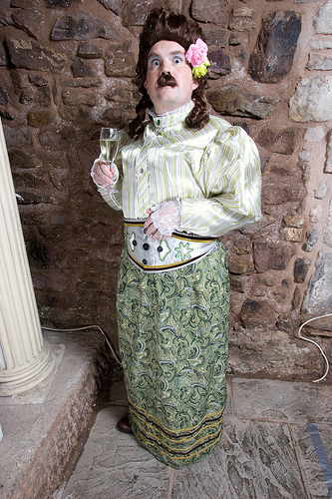

Act 1 Scene 5
- Rita is upset. Rita is having an “affair” with literature and not devoting enough time her marriage with Denny. This enrages Denny, especially when he finds that she is not taking the pill.
- She says she is “busy enough findin’ meself, let alone findin’ someone else”
  - She is self-absorbed in her pursuit of self-discovery that she ignores those around her
- Rita says, the old Rita, Susan, “is gone, an’ I’ve taken her place”
  - The use of third person creates a distinction between the two Ritas
  - It’s the only thing that makes her feel alive, which contrasts with the diseased state she believes the world is in
- The roles start to reverse in this scene, when Frank wants to discuss mundane matters (Denny), while Rita wants to discuss “things that matter”, such as Chekhov
- They decide to go to an amateur production of The Importance of Being Earnest
Relation to “Intro the World”
- Shows her resilience and determination
- It costs both the cost of moving into the world and what Rita is willing to give up on her journey
- Denny burns her books, which alludes to the attempt of governments around the world to suppress ideas when people desire new “worlds”
- Rita is surreptitiously thwarting Denny’s goal, while pursuing her own. This hypocrisy and deception will end when Denny discovers the pills.

Quotes from Scene | Technique and Relation to Into the World
He burnt all me books
He’s wonderin’ where the girl he married has gone to
It’s providing me with life itself
I’ve begun to find me—an’ it’s great
Oh y’ an awful snob, aren’t y’?
...hurry up – I’m dead excited. I’ve never seen a live play before.

Questions from scene:
- What is the major transition in this scene for Rita?
- What is the major transition for Rita and Frank’s relationship?

Act One Scene Six
- Rita is excited about visiting Frank to tell him the news that she visited Macbeth, which she thought was “bleedin’ great”
- Distinction of “tragedy” versus “tragic”
  - What is the difference?
  - How is this significant for Rita’s journey?
- Rita looks at students and says, “All them out there, they know all about that sort of thing don’t they?”
  - She is aware that she is not a “proper student” yet
Relation to “Into the World”
- Frank invites Rita to a dinner party at his house
  - This marks a change in Rita as their worlds are merging
- Rita’s growing openness and Frank’s concern for Rita, marks a change in their relationship. The gap between student and teacher is closing.
- Macbeth is the story of a person who desperately wants to leave the world of servitude to the king and commits regicide to enter the world of kingship.
  - Is this a clever allusion? If so, please explain?
- Window Symbolism

Act 2 Scene 1
- “Rita bursts through the door”
- Rita has just come back from summer school in London
- Rita asks to sit on the lawn
- Rita struggles to open the window after losing the battle to go outside
- Franks has a drink which Rita chides him for. He takes out William Blake only to find that Rita has studied it.
Into the World
- Rita is more confident
- “Rita bursts through the door. She is dressed in new, second-hand clothes (49)
  - New, but second hand ideas? A try hard?
- You don’t do Blake without doing innocence and experience” (p. 56)
- The room is no longer enough for Rita. Frank is no longer able to be her sole leader on her journey into experience

Act 2 Scene 2
- Speaks in a new voice
- Frank comments on how she seems willing to fall in love and leave the country
- He tells her that the essay would not be out of place with those of ‘proper students’

Into the World
- Rita ‘[knocks] at the door’
- ‘peculiar voice’
- ‘I have merely decided to talk properly. As Trish says there is not a lot of point in discussing beautiful literature in an ugly voice’ (56)
- Frank says “just be yourself” (57)
- “with me right in the middle of it” (58)
- “accepted ritual, the game and the rules” (28)

Act 1 Scene 7
- Rita explained to Frank why she didn’t attend the party

http://www.youtube.com/watch?v=dC0wJvsNQMA&feature=related

Act Two Scene Three

- Frank is drunk
- Reported by students for showing up to a lecture drunk
- Says that he gave the best lecture of his life
- Discuss an essay on “the Blossom” by Blake
  - Discovered “a vein” of “concealed meaning”
- Frank objects to her “trendy” ideas and Rita contests that she is being “objective”
- Frank pathetically tries to connect with her by discussing the Rubyfruit Jungle

Into the World
- She feels free to move in his room, which is a microcosm for the larger academic world
- Whereas she love his “crazy mad piss artist” antics, she takes an establishment view
- Frank warns her to “be careful”

